14.88: a) The volume V of the rock is

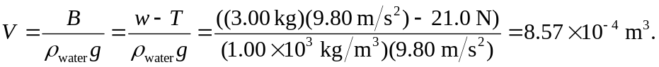

In the accelerated frames, all of the quantities that depend on g (weights, buoyant forces, gauge pressures and hence tensions) may be replaced by 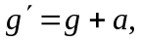 with the positive direction taken upward. Thus, the tension is 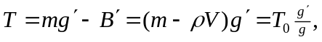 where 